ARSIA Complete Solution Design
Cross Jurisdictional Road Safety Data Integration Prototype
NSW VIC and QLD | 2020 to 2024 analytical scope
This document defines the complete technical design for the ARSIA Assignment 2 prototype. It aligns the Assignment 1 recommendations with the selected seven source files and the requirement for a working implementation in the provided Lab Environment.

1 Solution Architecture

1.1 Design objectives
- Integrate road-safety data from NSW, Victoria and Queensland.
- Preserve source fields and jurisdiction-specific classifications.
- Manage different crash, unit, participant and location grains.
- Retain dataset release, lineage and ETL-run information.
- Apply governed severity mappings for analytical comparison.
- Support crash trends, severity, unit involvement and spatial analysis.
- Run end to end in the provided Lab Environment.

1.2 Prototype technology choice
- PostgreSQL provides the core prototype database.
- PostGIS provides spatial fields, validation and map-oriented queries.
- SQL creates schemas, synthetic data, ETL logic, reporting views and tests.
- Python or Power BI presents the dashboards.
- GitHub stores code and the recorded demonstration link.
Microsoft Fabric remains the future production architecture proposed in Assignment 1. For Assignment 2, PostgreSQL schemas reproduce the same layers with fewer environment dependencies while retaining the selected Data Vault, relational and dimensional responsibilities.
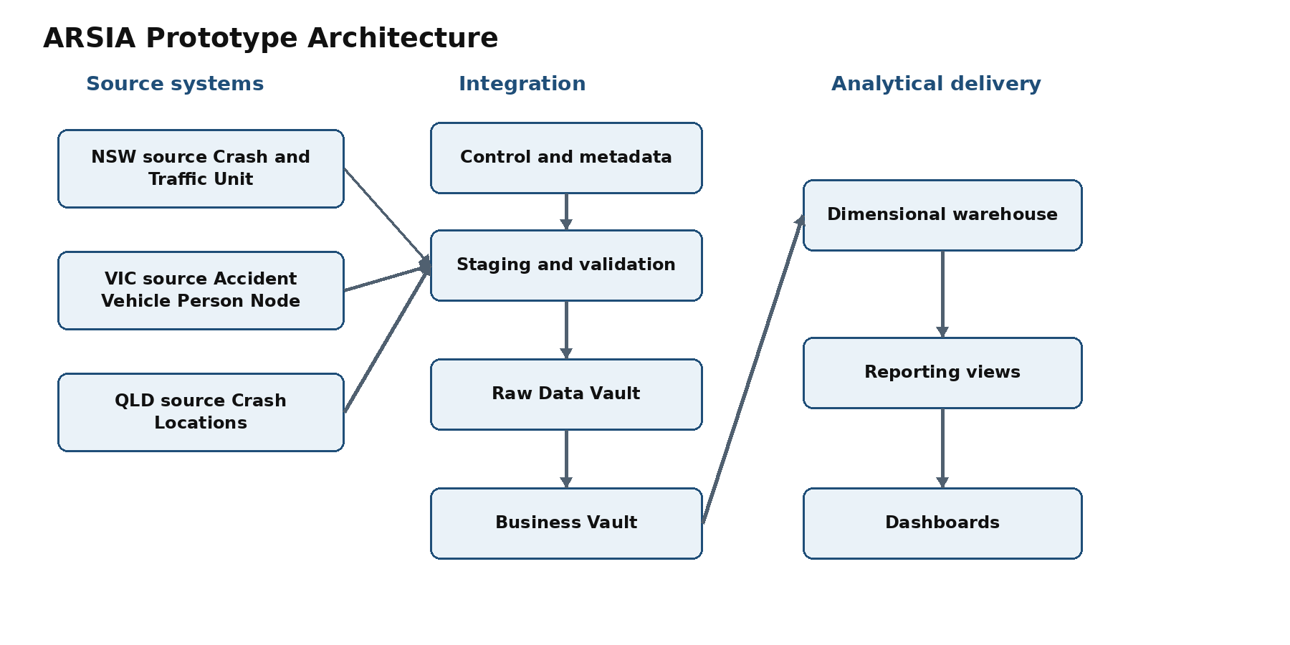
Figure 1 ARSIA prototype solution architecture

1.3 PostgreSQL schema responsibilities
Schema | Responsibility
source_nsw | Preserves the NSW source structure.
source_vic | Preserves the VIC source structure.
source_qld | Preserves the QLD source structure.
control | Stores releases, ETL runs, quality rules and mapping rules.
staging | Standardises types and fields, deduplicates records and flags exceptions.
raw_vault | Preserves business keys, source relationships, provenance and history.
business_vault | Applies governed mappings and calculated business rules.
warehouse | Provides the dimensional analytical warehouse.
reporting | Provides stable views for reports and dashboards.

2 Conceptual Data Model
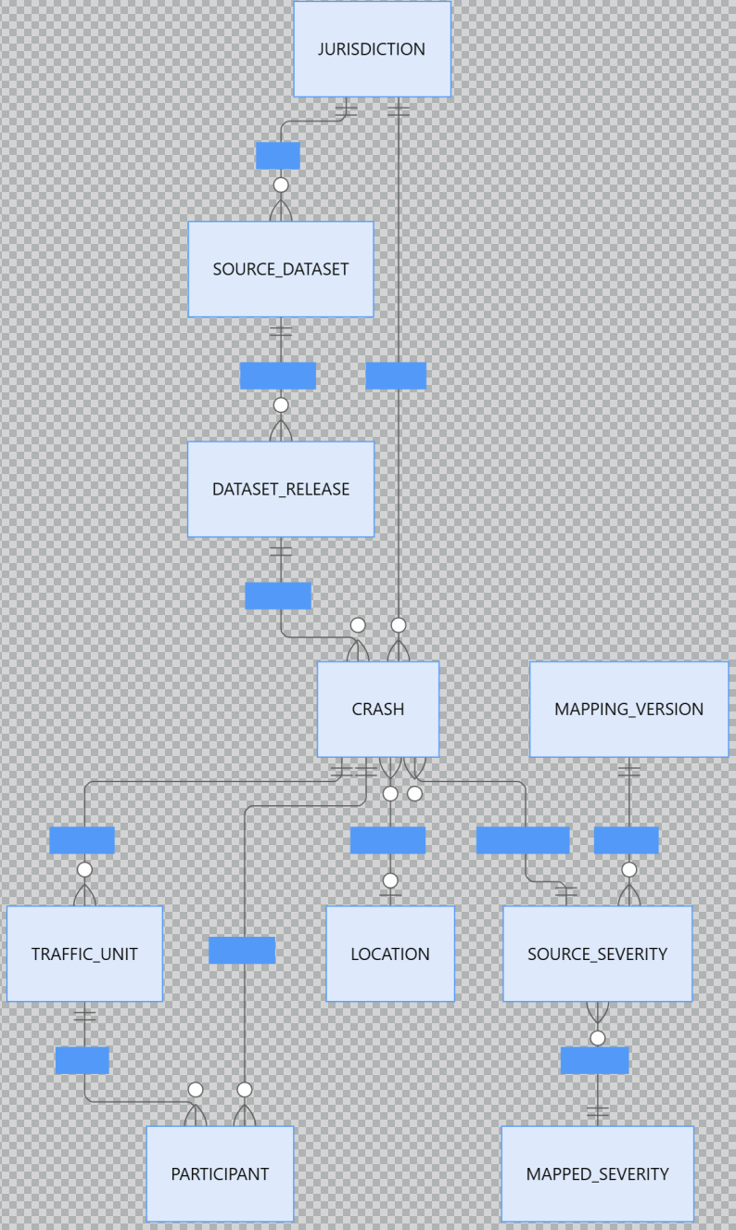
Figure 2 ARSIA conceptual data model

2.1 Entity definitions
Entity | Grain and purpose
Jurisdiction | One state or jurisdiction.
Source Dataset | One official data resource.
Dataset Release | One published version of a source dataset.
Crash | One road crash.
Traffic Unit | One vehicle or traffic unit involved in a crash.
Participant | One person involved in a crash.
Location | A location associated with a crash.
Source Severity | The original jurisdiction-specific severity classification.
Mapped Severity | The harmonised analytical severity category.
Mapping Version | A versioned set of mapping rules.
ETL Run | One execution of the data-processing pipeline.

2.2 Core business rules
- The Crash business key is jurisdiction_code plus source_crash_id.
- The same source identifier in different jurisdictions does not identify the same crash.
- NSW and VIC can supply individual unit records. Only VIC supplies individual participant records in the selected sources.
- QLD supplies crash-level aggregate unit and casualty counts; the prototype must not create artificial detail records.
- Crashes without coordinates remain eligible for nonspatial analysis.
- Original severity values remain unchanged and mapped values never overwrite them.
- Every mapped category retains its mapping version.
- Crash, unit and participant grains remain separate to prevent double counting.

3 Logical Data Model

3.1 Source system tables
Schema and table | Grain | Key
source_nsw.crash | One row per crash | crash_id
source_nsw.traffic_unit | One row per traffic unit within a crash | crash_id + traffic_unit_id
source_vic.accident | One row per accident | accident_no
source_vic.vehicle | One row per vehicle within an accident | accident_no + vehicle_id
source_vic.person | One row per participant within an accident | accident_no + person_id
source_vic.node | One source location or area row | source_node_row_id; accident_no and node_id retained
source_qld.crash_location | One crash with aggregate counts | crash_ref_number

3.2 Source table attributes
Table | Core attributes
source_nsw.crash | crash_id, degree_of_crash, degree_of_crash_detailed, reporting_year, year_of_crash, month_of_crash, day_of_week_of_crash, two_hour_intervals, street_of_crash, town, latitude, longitude, lga, road_surface, weather, speed_limit, dca_code, number_traffic_units, number_killed, number_seriously_injured, number_moderately_injured, number_minor_other_injured, release_key
source_nsw.traffic_unit | crash_id, traffic_unit_id, tu_controlled_flag, tu_role_first_impact, tu_type_group, street_of_travel, direction_of_travel, manoeuvre, object_hit_1, object_hit_2, release_key
source_vic.accident | accident_no, accident_date, accident_time, accident_type, accident_type_desc, day_of_week, dca_code, dca_desc, node_id, number_vehicles, number_persons_killed, number_persons_inj_2, number_persons_inj_3, number_persons_not_injured, number_persons, severity, speed_zone, release_key
source_vic.vehicle | All 37 source fields are retained. Core fields include accident_no, vehicle_id, vehicle_year_manuf, initial_direction, road_surface_type, road_surface_type_desc, vehicle_body_style, vehicle_make, vehicle_model, vehicle_type, vehicle_type_desc, total_no_occupants, final_direction, driver_intent, vehicle_movement, traffic_control, traffic_control_desc and release_key.
source_vic.person | accident_no, person_id, vehicle_id, sex, age_group, inj_level, inj_level_desc, seating_position, helmet_belt_worn, road_user_type, road_user_type_desc, licence_state, taken_hospital, ejected_code, release_key
source_vic.node | source_node_row_id, accident_no, node_id, node_type, amg_x, amg_y, lga_name, lga_name_all, deg_urban_name, latitude, longitude, postcode_crash, release_key
source_qld.crash_location | All 52 source fields are retained. Core fields include crash_ref_number, crash_severity, crash_year, crash_month, crash_day_of_week, crash_hour, crash_nature, crash_type, crash_longitude, crash_latitude, crash_street, crash_street_intersecting, loc_suburb, loc_local_government_area, loc_post_code, crash_speed_limit, crash_road_surface_condition, crash_atmospheric_condition, crash_lighting_condition, crash_dca_code, crash_dca_description, five casualty-count fields, seven unit-category count fields and release_key.

3.3 Control tables
Table | Principal fields
control.dataset_release | release_key, jurisdiction_code, dataset_name, release_version, source_filename, record_grain, file_checksum, period_start, period_end, loaded_at
control.etl_run | etl_run_id, started_at, completed_at, status, rows_read, rows_loaded, rows_rejected, error_message
control.severity_mapping | mapping_key, jurisdiction_code, source_severity_code, source_severity_label, mapped_severity_code, mapping_version, effective_from, effective_to, approved_flag

The harmonised severity codes are FATAL, SERIOUS_INJURY, OTHER_INJURY, NON_INJURY and UNKNOWN.
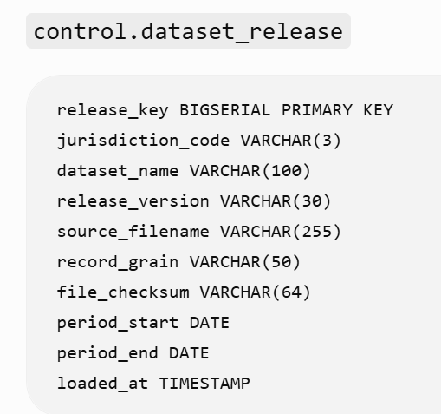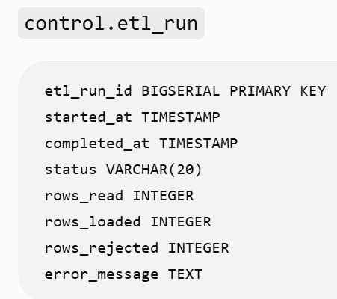

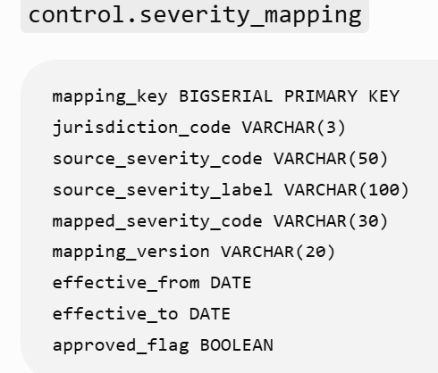

4 Data Vault Integration Model
The prototype implements a minimal Data Vault so that the working system remains consistent with the Assignment 1 recommendation.

4.1 Hubs
Hub | Business key
hub_crash | jurisdiction_code + source_crash_id
hub_unit | jurisdiction_code + source_crash_id + source_unit_id
hub_participant | jurisdiction_code + source_crash_id + source_person_id
hub_location | Jurisdiction-qualified location identifier or generated location hash
hub_dataset | jurisdiction_code + dataset_name + release_version

Each Hub contains a hash key, business key, load_datetime and record_source.

4.2 Links
Link | Relationship
link_crash_unit | Crash to Unit
link_crash_participant | Crash to Participant
link_unit_participant | Unit to Participant
link_crash_location | Crash to Location
link_crash_dataset | Crash to Dataset Release

4.3 Satellites
Satellite | Content
sat_crash_source | Time, casualties, road conditions and original classification.
sat_unit_source | Unit type, direction and manoeuvre.
sat_participant_source | Age group, sex, road-user type and injury level.
sat_location_source | Coordinates, LGA, postcode and location quality.
sat_crash_mapping | Mapped severity and mapping version.

Satellites retain parent_hash_key, load_datetime, load_end_datetime, record_source, release_key, hash_diff and source attributes. A changed attribute in a new release creates a new Satellite version; the Hub and prior Satellite record remain unchanged.

5 Data Warehouse Schema
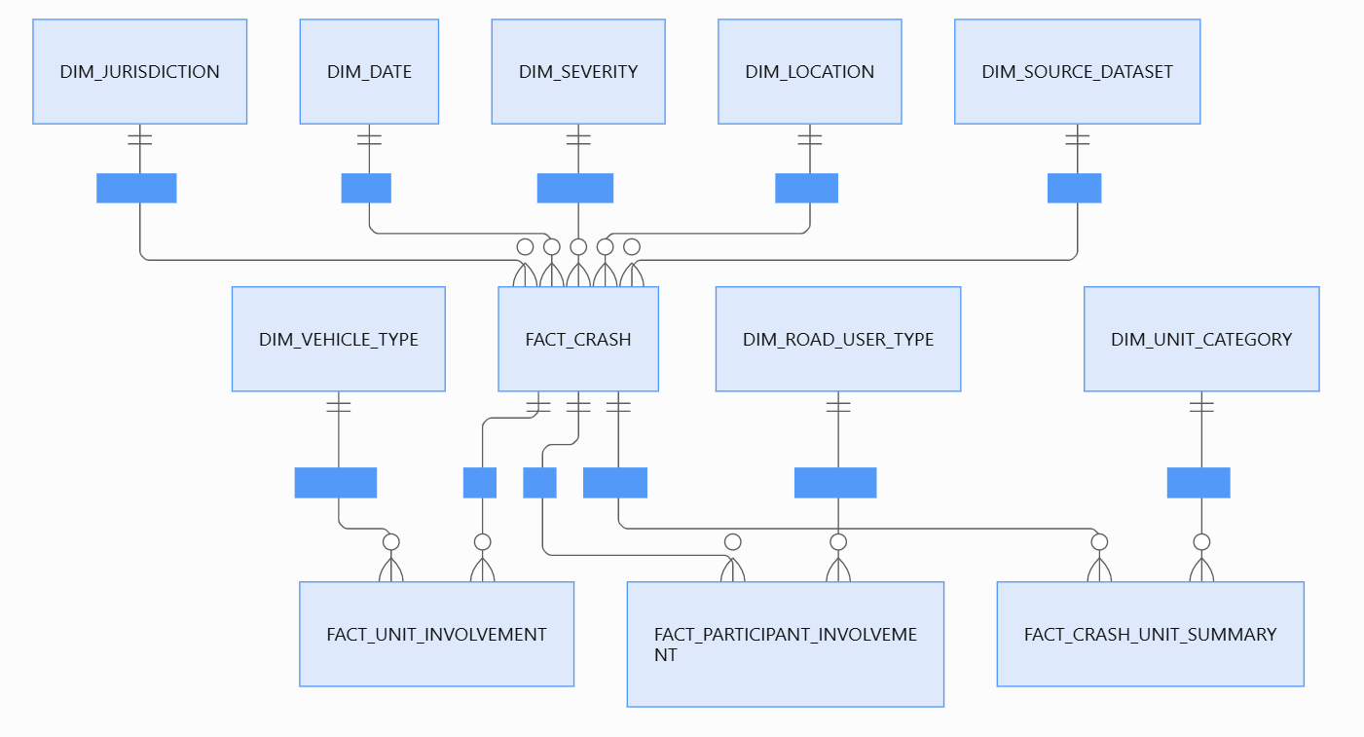

5.1 Dimensions
Dimension | Principal attributes
dim_jurisdiction | jurisdiction_key, jurisdiction_code, jurisdiction_name
dim_date | date_key, full_date, year, quarter, month_number, month_name, day_of_week, date_precision
dim_severity | severity_key, mapped_severity_code, mapped_severity_label, mapping_version, valid_from, valid_to, current_flag
dim_location | location_key, jurisdiction_code, lga_name, suburb_or_town, postcode, latitude, longitude, geometry, spatial_available_flag, location_quality_code
dim_source_dataset | source_dataset_key, jurisdiction_code, dataset_name, release_version, record_grain, file_checksum, loaded_at
Additional dimensions | dim_vehicle_type, dim_unit_category, dim_road_user_type and dim_time_band

VIC records use DAY date precision. NSW and QLD records use MONTH precision. A technical first-of-month date may support joins, but date_precision must prevent it from being interpreted as an exact crash date.

5.2 Fact tables
Fact table | Declared grain | Main measures and controls
fact_crash | One row per crash | crash_count fixed at 1; fatality, serious-injury, moderate-injury, minor-injury and casualty counts; reported unit and person counts; mapping and lineage keys
fact_unit_involvement | One row per unit within a crash | unit_count fixed at 1; source_unit_id, vehicle_type_key, direction, manoeuvre and lineage keys; NSW and VIC only
fact_participant_involvement | One row per VIC participant | participant_count fixed at 1; optional unit_fact_key, age group, sex, road-user type, injury level and lineage keys
fact_crash_unit_summary | One row per crash and unit category | reported_unit_count and measurement_type; derived from detail for NSW/VIC and source-reported aggregate for QLD

fact_crash fields: crash_key, source_crash_id, jurisdiction_key, date_key, severity_key, location_key, source_dataset_key, original_severity, fatality_count, serious_injury_count, moderate_injury_count, minor_injury_count, total_casualty_count, reported_unit_count, reported_person_count, crash_count, spatial_available_flag, mapping_key and etl_run_id. crash_count is fixed at 1. fact_crash enforces uniqueness across jurisdiction_key, source_crash_id and source_dataset_key.

fact_unit_involvement fields: unit_fact_key, crash_key, source_unit_id, vehicle_type_key, initial_direction, manoeuvre, unit_count, source_dataset_key and etl_run_id. unit_count is fixed at 1.

fact_participant_involvement fields: participant_fact_key, crash_key, unit_fact_key, source_person_id, road_user_type_key, sex_code, age_group, injury_level, participant_count, source_dataset_key and etl_run_id. unit_fact_key may be NULL when a participant cannot be matched to a vehicle.

fact_crash_unit_summary fields: crash_unit_summary_key, crash_key, unit_category_key, reported_unit_count, measurement_type, source_dataset_key and etl_run_id. measurement_type is DERIVED_FROM_DETAIL for NSW and VIC and SOURCE_REPORTED_AGGREGATE for QLD. This table allows three states to compare the number of unit categories while retaining differences in measurement methods
QLD aggregate values are not expanded into artificial unit records.

6 Source to Target Mapping

6.1 Crash identifier and time mapping
Target | NSW Crash | VIC Accident | QLD Crash
jurisdiction_code | Constant NSW | Constant VIC | Constant QLD
source_crash_id | Crash ID | ACCIDENT_NO | Crash_Ref_Number
crash_year | Year of crash | Year from ACCIDENT_DATE | Crash_Year
crash_month | Month of crash | Month from ACCIDENT_DATE | Crash_Month
crash_date | NULL | ACCIDENT_DATE | NULL
date_precision | MONTH | DAY | MONTH
day_of_week | Day of week of crash | DAY_WEEK_DESC | Crash_Day_Of_Week
time_detail | Two-hour intervals | ACCIDENT_TIME | Crash_Hour
release_key | Current NSW release | Current VIC release | Current QLD release

The NSW eligibility filter uses Year of crash rather than Reporting year.

6.2 Severity and casualty mapping
Target | NSW | VIC | QLD
original_severity_code | Degree of crash | SEVERITY | Crash_Severity
original_severity_label | Degree of crash - detailed | Description resolved from the VIC code | Crash_Severity
fatality_count | No. killed | NO_PERSONS_KILLED | Count_Casualty_Fatality
serious_injury_count | No. seriously injured | NO_PERSONS_INJ_2 | Count_Casualty_Hospitalised
moderate_injury_count | No. moderately injured | NO_PERSONS_INJ_3 | Count_Casualty_MedicallyTreated
minor_injury_count | No. minor-other injured | No direct equivalence assumed | Count_Casualty_MinorInjury
total_casualty_count | Sum of casualty fields | Sum of casualty fields | Count_Casualty_Total
mapped_severity | Versioned mapping table | Versioned mapping table | Versioned mapping table

VIC NO_PERSONS includes uninjured people and is therefore not used as total_casualty_count.

6.3 Location mapping
Target | NSW Crash | VIC Node | QLD Crash
source_location_id | Generated from Crash ID | NODE_ID | Generated from Crash Ref
latitude | Latitude | LATITUDE | Crash_Latitude
longitude | Longitude | LONGITUDE | Crash_Longitude
lga_name | LGA | LGA_NAME | Loc_Local_Government_Area
suburb_or_town | Town | NULL | Loc_Suburb
postcode | NULL | POSTCODE_CRASH | Loc_Post_Code
geometry | Coordinate conversion | Coordinate conversion | Coordinate conversion
spatial_available | Coordinate validation | Coordinate validation | Coordinate validation

The common geometry is EPSG 4326 POINT(longitude latitude). VIC AMG_X and AMG_Y are not substituted for latitude and longitude unless their coordinate reference system is validated.

6.4 Unit and participant mapping
Target | NSW Traffic Unit | VIC Vehicle
source_crash_id | Crash ID | ACCIDENT_NO
source_unit_id | Traffic unit ID | VEHICLE_ID
vehicle_type_original | TU type group | VEHICLE_TYPE_DESC
initial_direction | Direction of travel | INITIAL_DIRECTION
final_direction | Not supplied | FINAL_DIRECTION
manoeuvre | Manoeuvre | VEHICLE_MOVEMENT
road_surface_type | Not held in Unit table | ROAD_SURFACE_TYPE_DESC
occupant_count | Not supplied | TOTAL_NO_OCCUPANTS

Participant target | VIC Person source
source_crash_id | ACCIDENT_NO
source_person_id | PERSON_ID
source_unit_id | VEHICLE_ID
sex_code | SEX
age_group | AGE_GROUP
injury_level_code | INJ_LEVEL
injury_level_label | INJ_LEVEL_DESC
road_user_type_code | ROAD_USER_TYPE
road_user_type_label | ROAD_USER_TYPE_DESC
hospital_flag | TAKEN_HOSPITAL

6.5 QLD unit summary mapping
QLD source field | Harmonised category
Count_Unit_Car | CAR
Count_Unit_Motorcycle_Moped | MOTORCYCLE_MOPED
Count_Unit_Truck | TRUCK
Count_Unit_Bus | BUS
Count_Unit_Bicycle | BICYCLE
Count_Unit_Pedestrian | PEDESTRIAN
Count_Unit_Other | OTHER

Use SQL UNION ALL or horizontal conversion to convert 7 fields into 7 types of unit category records.

7 ETL Process

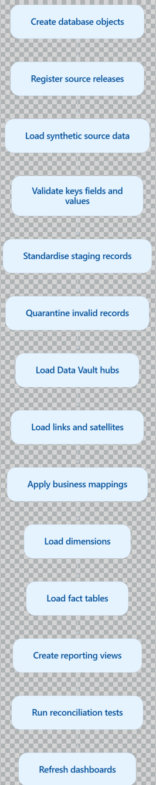

7.1 Extract
- Read data from the three source schemas.
- Add release_key and etl_run_id to each row.
- Do not modify the source tables.
- Record the number of rows read.

7.2 Validate
Validate:
- required columns;
- duplicate primary keys;
- parent-child relationships;
- whether the year falls within 2020–2024;
- whether the severity value is valid;
- latitude and longitude ranges;
- declared counts against detail-record counts;
- data types;
- null percentages.

7.3 Transform
NSW
- Use Year of crash to filter records for 2020–2024.
- Exclude 107 records for crashes that occurred in 2019.
- Standardise the Month text.
- Keep Crash and Traffic Unit data at separate grains.
VIC
- Extract the year and month from ACCIDENT_DATE.
- Retain only records from 2020–2024.
- Deduplicate Node records by accident, Node and coordinates.
- Process LGA NAME ALL separately.
- Join Vehicle and Person records separately to Accident.
- Send the 39 Person records with unmatched Vehicle references to the data-quality log.
QLD
- Retain only records where Crash_Year falls within 2020–2024.
- Transform the seven unit-count fields into a long-table structure.
- Retain records with missing latitude or longitude in the Crash fact table.
- Exclude records with missing locations from valid spatial views.
Common Transformations
- Create a jurisdiction-qualified business key.
- Retain the original severity.
- Apply versioned mappings to derive the mapped severity.
- Do not replace null values with zero unless the field definition explicitly states that a null value is equivalent to zero.
- Calculate spatial_available_flag.
- Generate PostGIS geometry.

7.4 Load order
- control.dataset_release
- Staging tables
- Data Vault Hubs
- Data Vault Links
- Data Vault Satellites
- Business Vault mappings
- Warehouse dimensions
- fact_crash
- fact_unit_involvement
- fact_participant_involvement
- fact_crash_unit_summary
- Reporting views
Processing runs within controlled transactions. A severe error causes rollback and updates control.etl_run with a failed status and diagnostic message.

8 Report and Dashboard Design

8.1 Dashboard 1 Cross State Crash Trends
Purpose: compare crash trends across NSW, Victoria and Queensland from 2020 to 2024.

8.2 Dashboard 2 Severity and Casualty Comparison
Purpose: compare severity and casualty outcomes across the three jurisdictions.

8.3 Dashboard 3 Spatial Crash Distribution
Purpose: show the geographical distribution of recorded crashes and the coverage of spatial data.

8.4 Dashboard 4 Unit Involvement
Purpose: compare vehicle and road-user categories.

8.5 Dashboard 5 Data Quality and Lineage
Can be used as an additional dashboard
The minimum requirement for homework is 3

9 End to End Testing Plan

9.1 Synthetic-data coverage
- At least a few normal crashes in each state;
- A reporting year in NSW that differs from a crash year;
- VIC duplicate nodes;
- VIC Vehicle declared count inconsistent;
- VIC Person cannot connect to Vehicle;
- QLD missing coordinates;
- Duplicate source crash IDs appear in different states;
- Unknown severity;
- The same accident attribute has changed in the new release.

9.2 Test cases
ID | Test | Expected result
T01 | Create all schemas and tables | All objects are created without SQL errors.
T02 | Load three synthetic source systems | All source schemas contain the expected records.
T03 | Use the same Crash ID in different states | Two distinct jurisdiction-qualified crashes are created.
T04 | Join parent and child records | Valid units and participants link to the correct crashes.
T05 | Load duplicate VIC Nodes | Staging retains one valid location and logs duplicate evidence.
T06 | Load a VIC Person without a matching Vehicle | The participant is retained where the Crash link is valid and the exception is logged.
T07 | Load a QLD crash without coordinates | The crash enters fact_crash with spatial_available_flag set to false.
T08 | Load an unknown severity | The source value remains and the mapped value becomes UNKNOWN.
T09 | Count crashes after joining units | The distinct crash count remains equal to fact_crash and is not multiplied by unit rows.
T10 | Compare declared and derived counts | Mismatches appear in the quality results.
T11 | Load a changed record in a second release | The Hub remains stable and the Satellite receives a new version.
T12 | Re-run the same release | No duplicate business or fact records are created.
T13 | Reconcile warehouse totals | Warehouse totals match accepted staging records.
T14 | Check dashboard measures | Displayed values match manually predetermined synthetic-data results.
T15 | Lineage testing | The results can be traced back to release and ETL run

9.3 Key SQL Acceptance Logic
The number of crashes must be calculated using:
COUNT(DISTINCT crash_key)
rather than directly using the following after joining Crash and Unit:
COUNT(*)
ETL reconciliation should satisfy:
source rows
= accepted staging rows
+ rejected rows
+ deliberately excluded rows
Spatial reconciliation should satisfy:
all eligible crashes
= spatially usable crashes
+ missing or invalid coordinate crashes

9.4 End-to-End Demonstration Sequence
- Present the architecture diagram and the three source systems;
- Run the table creation scripts starting from an empty database;
- Insert synthetic data;
- Display the source tables;
- Execute the ETL process;
- Demonstrate the handling of duplicates, missing values and exceptions;
- Display the Data Vault historical records;
- Display the warehouse fact and dimension tables;
- Execute the test scripts;
- Present at least three dashboards;
- Trace a dashboard record back to the dataset release;
- Show that all tests have passed.

10. Recommended SQL File Structure
01_extensions_and_schemas.sql
02_control_tables.sql
03_nsw_source_tables.sql
04_vic_source_tables.sql
05_qld_source_tables.sql
06_staging_tables.sql
07_raw_vault_tables.sql
08_business_vault_tables.sql
09_warehouse_tables.sql
10_synthetic_source_data.sql
11_source_validation.sql
12_transform_to_staging.sql
13_load_raw_vault.sql
14_apply_business_rules.sql
15_load_dimensions.sql
16_load_fact_tables.sql
17_reporting_views.sql
18_quality_tests.sql
19_end_to_end_test.sql
20_cleanup_demo.sql
The 19_end_to_end_test.sql file should be able to invoke or validate all components in the correct sequence.

11. Final Design Conclusion
This design is consistent with the existing materials:
- It uses three source systems from NSW, VIC and QLD;
- It uses all seven selected files;
- It applies a unified analysis period of 2020–2024;
- It preserves the different grains of Crash, Unit, Participant and Location;
- It uses Data Vault to preserve source data and history;
- It uses Business Vault to manage severity mappings;
- It uses a dimensional warehouse to support dashboards;
- It uses PostgreSQL/PostGIS to implement the Lab Environment prototype;
- Neo4j will not be implemented at this stage;
- It uses synthetic data to ensure that the prototype can run independently;
- It uses the structures and quality issues found in the real data to design test scenarios.

ARSIA Severity and Unit Category Mapping Specification
Version 1 | NSW VIC and QLD | 2020 to 2024 prototype
This specification defines the approved analytical mappings used by the ARSIA prototype. The source classifications remain unchanged and traceable. Harmonised categories support controlled comparison only and do not establish complete equivalence between jurisdictional definitions.

1 Severity Mapping Version 1

1.1 Harmonised severity categories
Code | Label | Definition
FATAL | Fatal crash | A crash in which at least one person was killed.
SERIOUS_INJURY | Serious injury crash | A harmonised analytical category for serious-injury or hospitalisation crashes.
OTHER_INJURY | Other injury crash | A crash involving moderate, minor, medical-treatment or other recorded injury.
NON_INJURY | Non-injury crash | A crash with no recorded casualty under the relevant source classification.
UNKNOWN | Unknown severity | A blank, unrecognised or currently unmapped source classification.

1.2 Jurisdiction severity mapping
State | Source field | Source value | Source description | Mapped category | Version | Approved
NSW | Degree of crash - detailed | Fatal | Fatal crash | FATAL | SEVERITY_V1 | TRUE
NSW | Degree of crash - detailed | Serious Injury | Serious injury crash | SERIOUS_INJURY | SEVERITY_V1 | TRUE
NSW | Degree of crash - detailed | Moderate Injury | Moderate injury crash | OTHER_INJURY | SEVERITY_V1 | TRUE
NSW | Degree of crash - detailed | Minor/Other Injury | Minor or other injury crash | OTHER_INJURY | SEVERITY_V1 | TRUE
NSW | Degree of crash - detailed | Non-casualty (towaway) | Non-casualty towaway crash | NON_INJURY | SEVERITY_V1 | TRUE
VIC | SEVERITY | 1 | Fatal accident | FATAL | SEVERITY_V1 | TRUE
VIC | SEVERITY | 2 | Serious injury accident | SERIOUS_INJURY | SEVERITY_V1 | TRUE
VIC | SEVERITY | 3 | Other injury accident | OTHER_INJURY | SEVERITY_V1 | TRUE
VIC | SEVERITY | 4 | Non-injury accident | NON_INJURY | SEVERITY_V1 | TRUE
QLD | Crash_Severity | Fatal | Fatal crash | FATAL | SEVERITY_V1 | TRUE
QLD | Crash_Severity | Hospitalisation | Hospitalisation crash | SERIOUS_INJURY | SEVERITY_V1 | TRUE
QLD | Crash_Severity | Medical treatment | Medical-treatment injury crash | OTHER_INJURY | SEVERITY_V1 | TRUE
QLD | Crash_Severity | Minor injury | Minor injury crash | OTHER_INJURY | SEVERITY_V1 | TRUE
ALL | Relevant severity field | NULL blank or unrecognised | Unknown or unmapped | UNKNOWN | SEVERITY_V1 | TRUE

1.3 Source-record validation counts
State | Source classification | Records
NSW | Fatal | 1,388
NSW | Serious Injury | 19,589
NSW | Moderate Injury | 26,115
NSW | Minor/Other Injury | 15,483
NSW | Non-casualty (towaway) | 29,507
VIC | Severity 1 | 1,182
VIC | Severity 2 | 24,401
VIC | Severity 3 | 46,584
VIC | Severity 4 | 3
QLD | Fatal | 1,304
QLD | Hospitalisation | 31,922
QLD | Medical treatment | 22,730
QLD | Minor injury | 10,668

- QLD Hospitalisation is mapped to SERIOUS_INJURY as an analytical grouping.
- NSW Moderate Injury and Minor/Other Injury are mapped to OTHER_INJURY.
- QLD Medical treatment and Minor injury are mapped to OTHER_INJURY.
- Every warehouse record retains its source severity, jurisdiction and mapping version.
- New or unrecognised values are mapped to UNKNOWN and logged as data-quality exceptions.

2 Unit Category Mapping Version 1

2.1 Harmonised unit categories
Code | Label
CAR | Car
MOTORCYCLE_MOPED | Motorcycle or moped
TRUCK | Truck or heavy vehicle
BUS | Bus or coach
BICYCLE | Bicycle
PEDESTRIAN | Pedestrian
OTHER | Other or unknown unit

2.2 NSW traffic unit mapping
NSW TU type group | Records | Mapped category | Version | Approved
Car/car derivative | 114,333 | CAR | UNIT_V1 | TRUE
Motorcycle | 11,002 | MOTORCYCLE_MOPED | UNIT_V1 | TRUE
Light truck | 25,312 | TRUCK | UNIT_V1 | TRUE
Heavy rigid truck | 3,502 | TRUCK | UNIT_V1 | TRUE
Articulated truck | 2,882 | TRUCK | UNIT_V1 | TRUE
Bus | 997 | BUS | UNIT_V1 | TRUE
Pedal cycle | 3,840 | BICYCLE | UNIT_V1 | TRUE
Pedestrian | 5,167 | PEDESTRIAN | UNIT_V1 | TRUE
Non-motorised vehicle | 412 | OTHER | UNIT_V1 | TRUE
Other motor vehicle | 2,924 | OTHER | UNIT_V1 | TRUE
Other or unknown | 376 | OTHER | UNIT_V1 | TRUE
NULL blank or unrecognised | Run-time | OTHER | UNIT_V1 | TRUE

2.3 VIC vehicle mapping
Code | VIC vehicle type description | Records | Mapped category | Version | Approved
1 | Car | 55,349 | CAR | UNIT_V1 | TRUE
2 | Station Wagon | 32,790 | CAR | UNIT_V1 | TRUE
3 | Taxi | 883 | CAR | UNIT_V1 | TRUE
4 | Utility | 12,380 | OTHER | UNIT_V1 | TRUE
5 | Panel Van | 3,036 | OTHER | UNIT_V1 | TRUE
6 | Prime Mover (No of Trailers Unknown) | 20 | TRUCK | UNIT_V1 | TRUE
7 | Rigid Truck (Weight Unknown) | 53 | TRUCK | UNIT_V1 | TRUE
8 | Bus/Coach | 513 | BUS | UNIT_V1 | TRUE
9 | Mini Bus (9-13 seats) | 150 | BUS | UNIT_V1 | TRUE
10 | Motor Cycle | 9,449 | MOTORCYCLE_MOPED | UNIT_V1 | TRUE
11 | Moped | 11 | MOTORCYCLE_MOPED | UNIT_V1 | TRUE
12 | Motor Scooter | 723 | MOTORCYCLE_MOPED | UNIT_V1 | TRUE
13 | Bicycle | 6,984 | BICYCLE | UNIT_V1 | TRUE
14 | Horse (ridden or drawn) | 13 | OTHER | UNIT_V1 | TRUE
15 | Tram | 273 | OTHER | UNIT_V1 | TRUE
16 | Train | 22 | OTHER | UNIT_V1 | TRUE
17 | Other Vehicle | 797 | OTHER | UNIT_V1 | TRUE
18 | Not Applicable | 11 | OTHER | UNIT_V1 | TRUE
19 | Parked trailers | 85 | OTHER | UNIT_V1 | TRUE
20 | Quad Bike | 54 | OTHER | UNIT_V1 | TRUE
21 | Electric Device | 149 | OTHER | UNIT_V1 | TRUE
27 | Plant machinery and Agricultural equipment | 141 | OTHER | UNIT_V1 | TRUE
60 | Prime Mover Only | 429 | TRUCK | UNIT_V1 | TRUE
61 | Prime Mover - Single Trailer | 1,030 | TRUCK | UNIT_V1 | TRUE
62 | Prime Mover B-Double | 174 | TRUCK | UNIT_V1 | TRUE
63 | Prime Mover B-Triple | 66 | TRUCK | UNIT_V1 | TRUE
71 | Light Commercial Vehicle (Rigid) <= 4.5 Tonnes GVM | 2,959 | OTHER | UNIT_V1 | TRUE
72 | Heavy Vehicle (Rigid) > 4.5 Tonnes | 1,791 | TRUCK | UNIT_V1 | TRUE
99 | Not Known | 2,037 | OTHER | UNIT_V1 | TRUE
NULL | Blank or unrecognised | Run-time | OTHER | UNIT_V1 | TRUE

2.4 Confirmed classification decisions
Source classification | Approved treatment
VIC Utility | OTHER
VIC Panel Van | OTHER
VIC Light Commercial Vehicle <= 4.5 tonnes | OTHER
VIC Quad Bike | OTHER
VIC Heavy Vehicle > 4.5 tonnes | TRUCK
VIC pedestrian | Derived from the Person table rather than the Vehicle table

3 VIC Pedestrian Treatment
VIC pedestrians are represented in vic_person.csv rather than vic_vehicle.csv. The prototype must not create artificial pedestrian vehicle records. VIC pedestrian involvement is derived where ROAD_USER_TYPE_DESC equals Pedestrians and is counted at person-record grain using ACCIDENT_NO and PERSON_ID.
Source table | Source field | Source value | Mapped category
vic_person | ROAD_USER_TYPE_DESC | Pedestrians | PEDESTRIAN

Because the comparison includes both vehicles and pedestrians, the dashboard should be titled Road User and Unit Involvement rather than Vehicle Type Analysis.

4 QLD Aggregate Unit Mapping
QLD does not provide individual unit records in the selected resource. Its seven crash-level count fields are transformed into category rows without creating synthetic vehicle records.
QLD source field | Mapped category | Measurement type
Count_Unit_Car | CAR | SOURCE_REPORTED_AGGREGATE
Count_Unit_Motorcycle_Moped | MOTORCYCLE_MOPED | SOURCE_REPORTED_AGGREGATE
Count_Unit_Truck | TRUCK | SOURCE_REPORTED_AGGREGATE
Count_Unit_Bus | BUS | SOURCE_REPORTED_AGGREGATE
Count_Unit_Bicycle | BICYCLE | SOURCE_REPORTED_AGGREGATE
Count_Unit_Pedestrian | PEDESTRIAN | SOURCE_REPORTED_AGGREGATE
Count_Unit_Other | OTHER | SOURCE_REPORTED_AGGREGATE

NSW and VIC category totals are marked DERIVED_FROM_DETAIL. QLD values are marked SOURCE_REPORTED_AGGREGATE. These measurement types remain visible in the warehouse and reporting layer.

5 Database Mapping Tables

5.1 Severity mapping table
CREATE TABLE control.severity_mapping (
jurisdiction_code VARCHAR(3) NOT NULL,
source_severity_code VARCHAR(50) NOT NULL,
source_severity_label VARCHAR(100),
mapped_severity_code VARCHAR(30) NOT NULL,
mapping_version VARCHAR(20) NOT NULL,
effective_from DATE NOT NULL,
effective_to DATE,
approved_flag BOOLEAN NOT NULL DEFAULT FALSE,
mapping_note TEXT,
PRIMARY KEY (jurisdiction_code, source_severity_code, mapping_version)
);

5.2 Unit category mapping table
CREATE TABLE control.unit_category_mapping (
jurisdiction_code VARCHAR(3) NOT NULL,
source_type_code VARCHAR(50) NOT NULL,
source_type_label VARCHAR(150) NOT NULL,
mapped_unit_category VARCHAR(30) NOT NULL,
mapping_version VARCHAR(20) NOT NULL,
approved_flag BOOLEAN NOT NULL DEFAULT FALSE,
mapping_note TEXT,
PRIMARY KEY (jurisdiction_code, source_type_code, mapping_version)
);

6 Implementation Controls
- Use SEVERITY_V1 and UNIT_V1 for the initial prototype load.
- Keep source codes and labels in every governed output required for lineage.
- Do not replace source values with harmonised values.
- Route blank or unrecognised values to UNKNOWN or OTHER and record a data-quality exception.
- Do not expand QLD aggregate counts into artificial individual unit records.
- Create a new version when a mapping changes. Do not overwrite Version 1.

7 Approval Record
Original jurisdictional classifications will be retained, and the harmonised categories will be used only for controlled analytical comparison. QLD unit counts will remain source-reported aggregate measures, while NSW and VIC unit counts will be derived from detail records.

